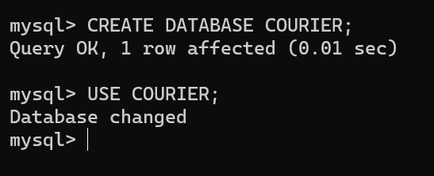

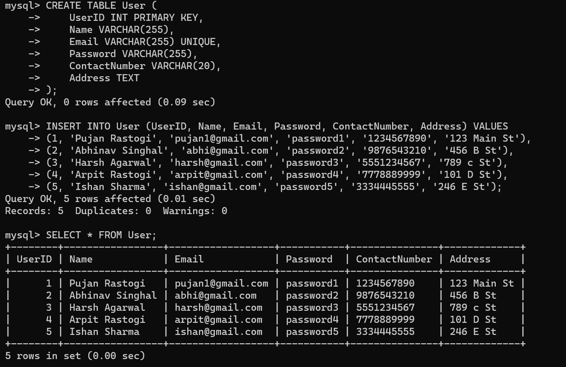

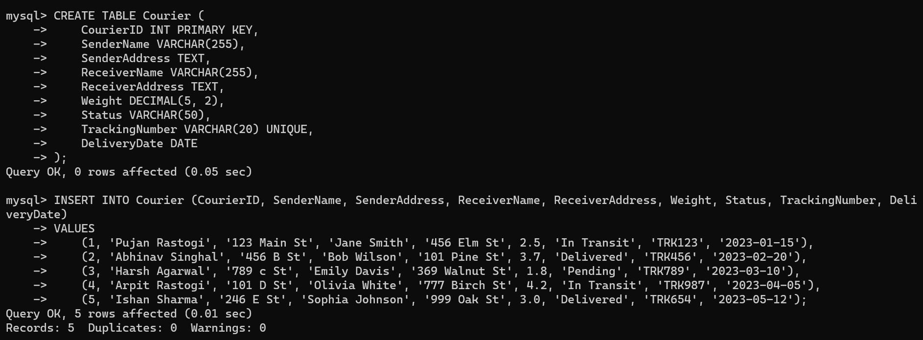

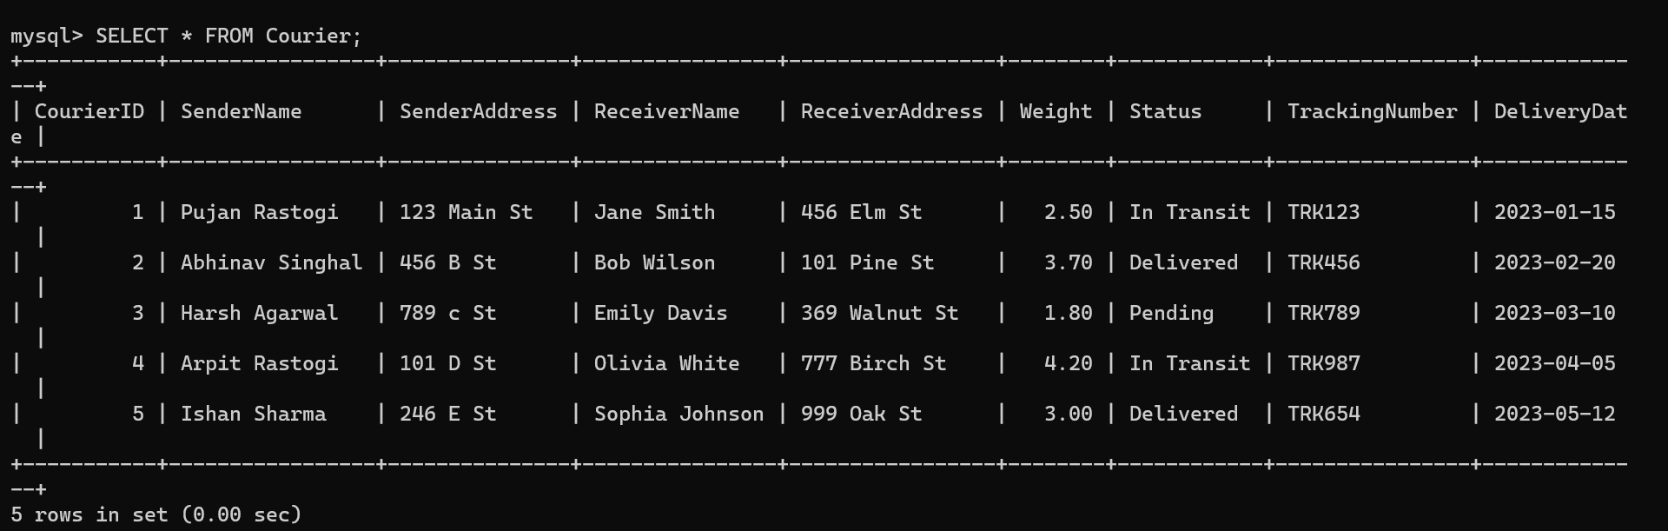

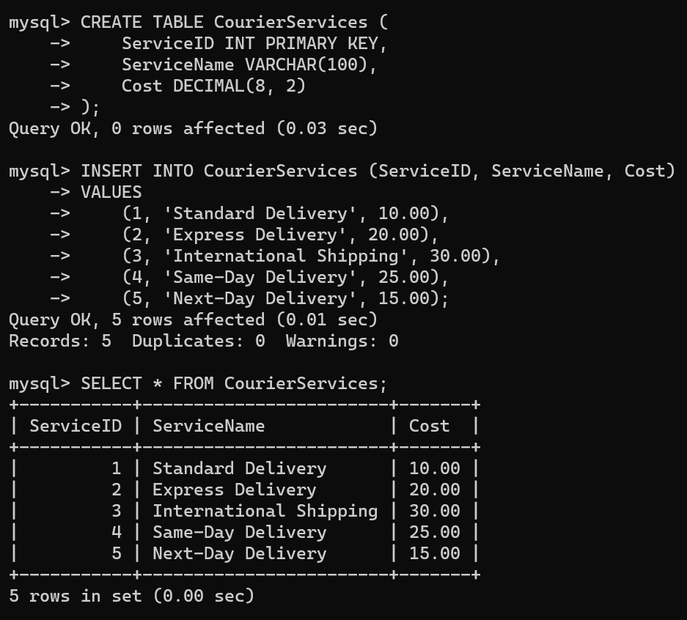

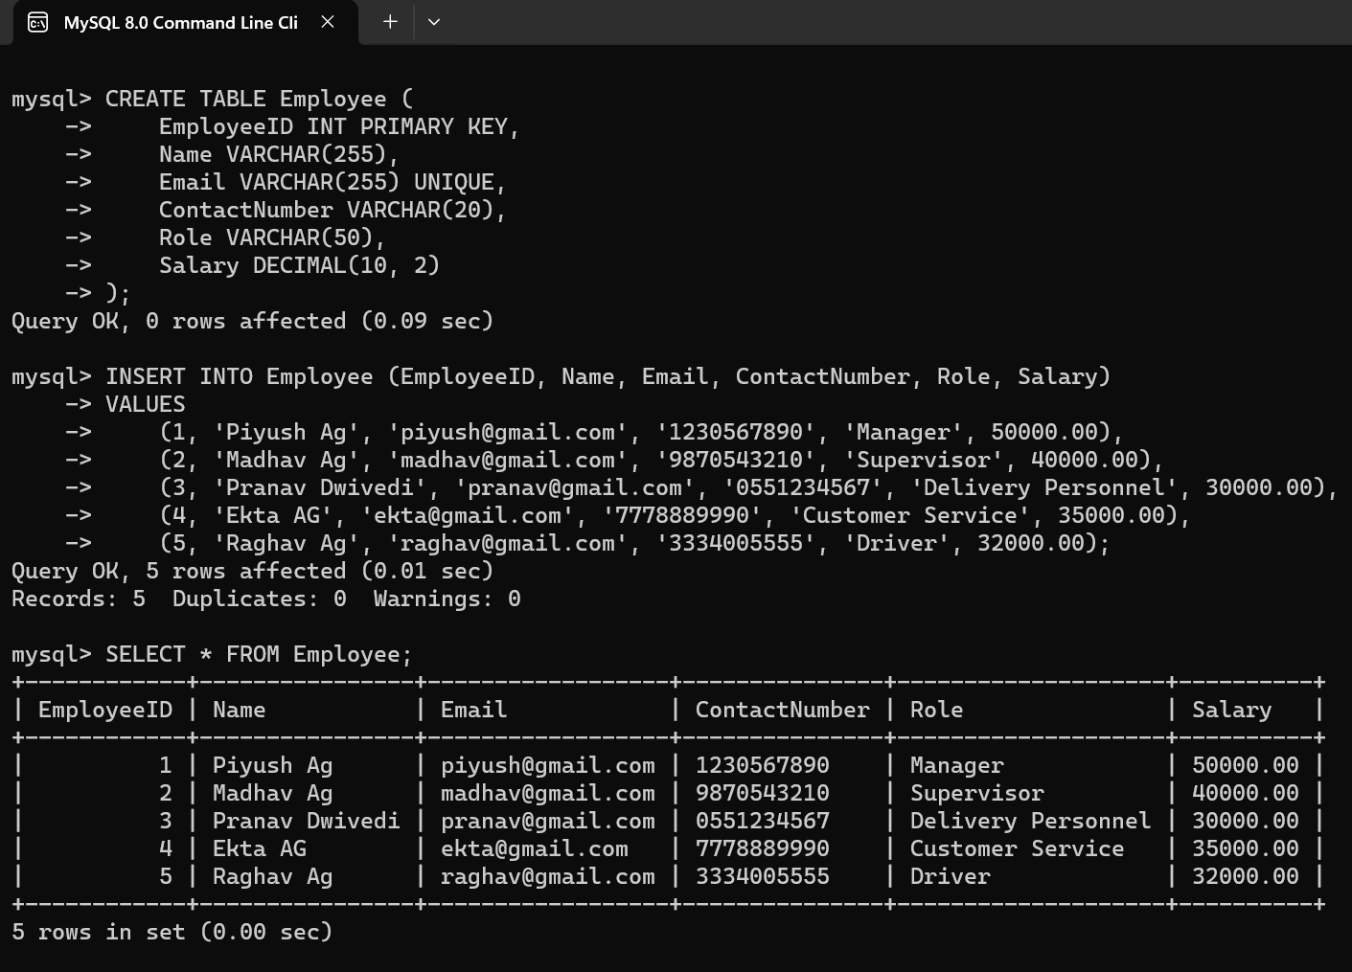

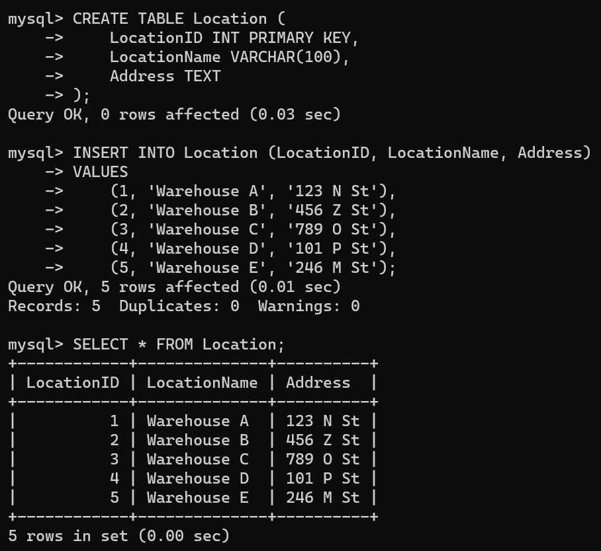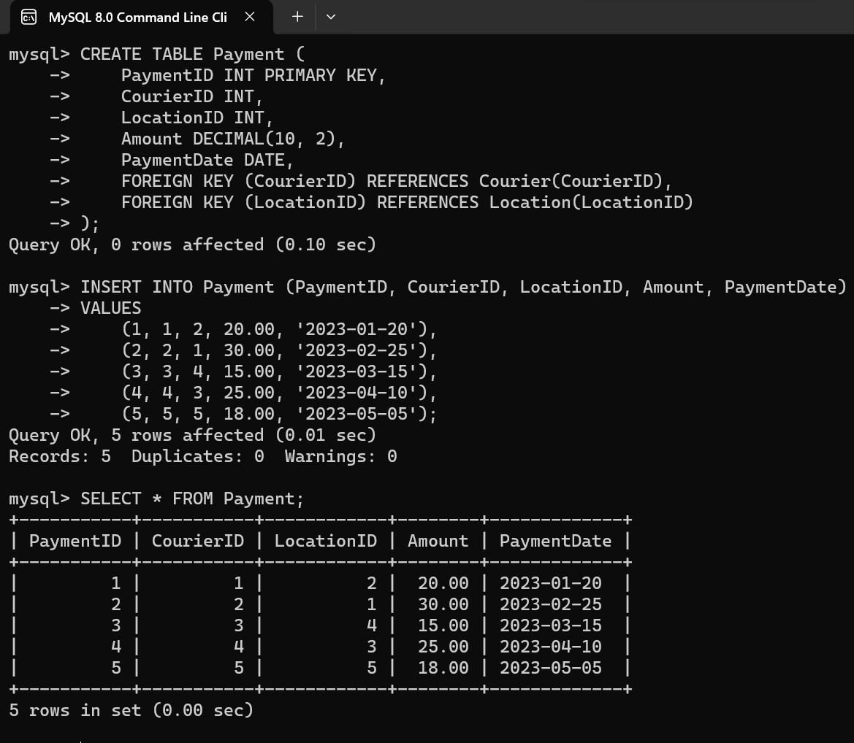

**Task 2: Select,Where**

**Solve the following queries in the Schema that you have created above**

**1. List all customers:**

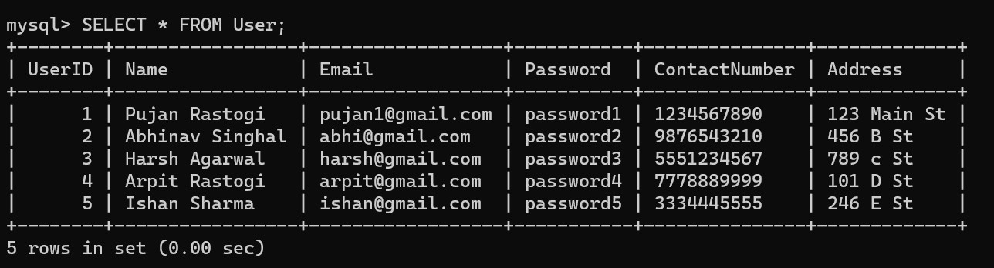

**2. List all orders for a specific customer:**

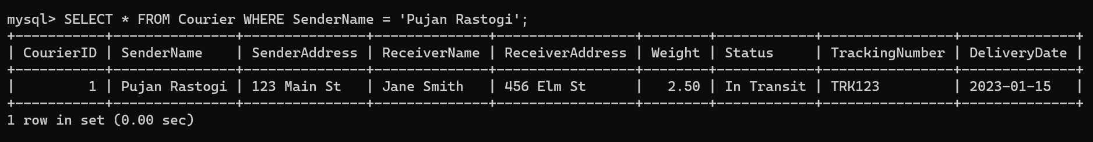

**3. List all couriers:**

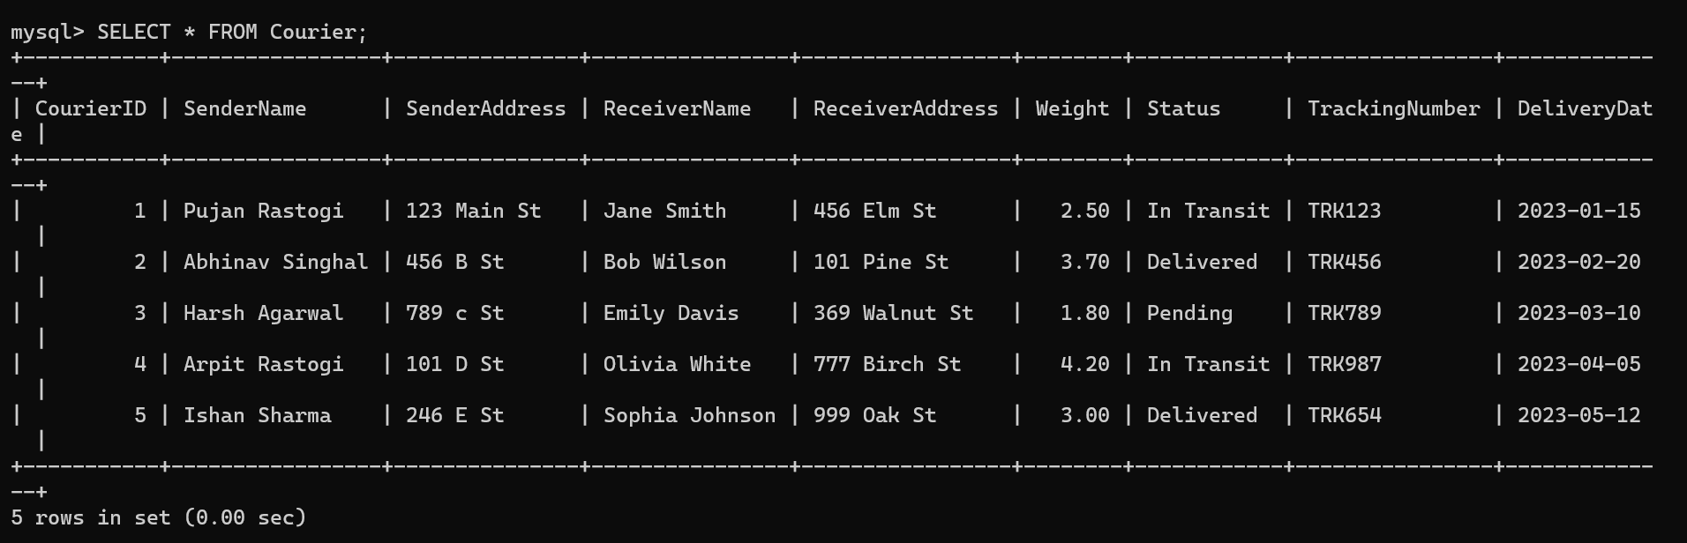

**4. List all packages for a specific order:**

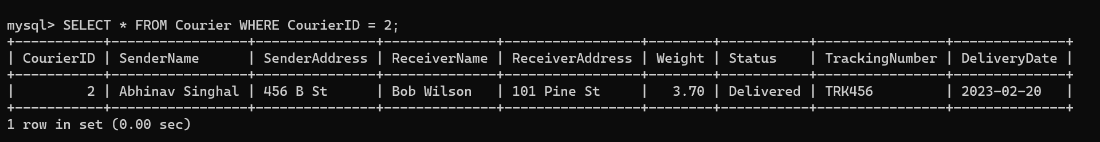

**5. List all deliveries for a specific courier:**



**6. List all undelivered packages:**

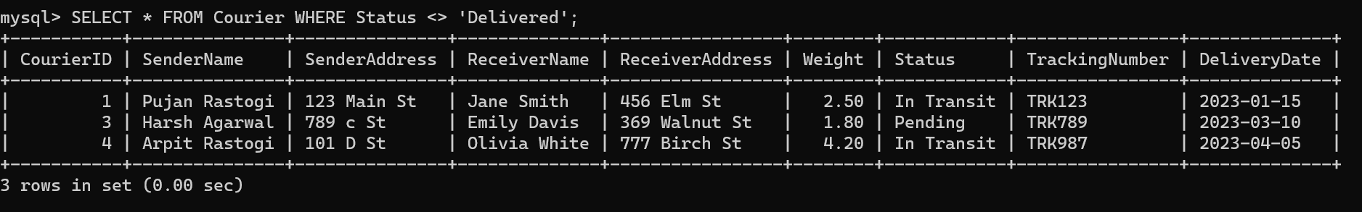

**7. List all packages that are scheduled for delivery today:**



**8. List all packages with a specific status:**

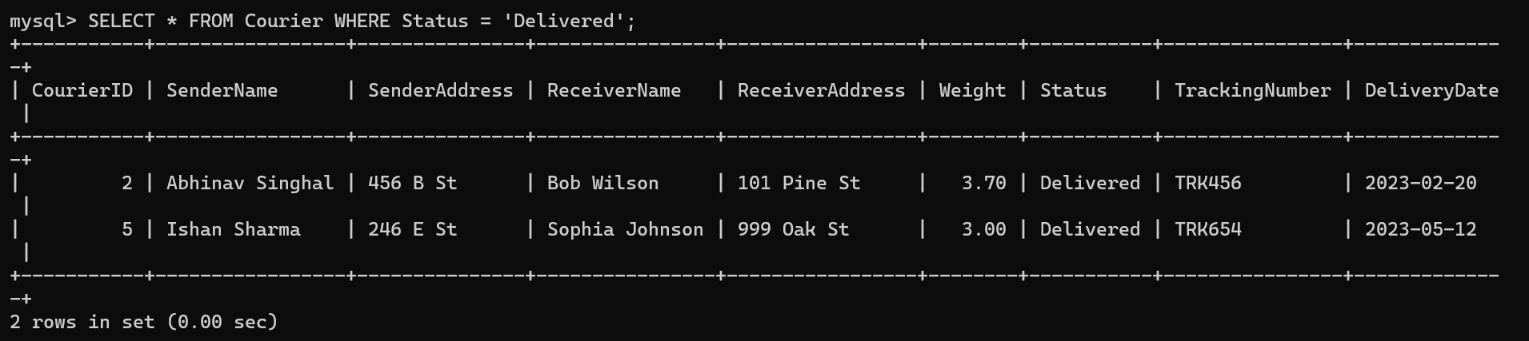

**9. Calculate the total number of packages for each courier.**

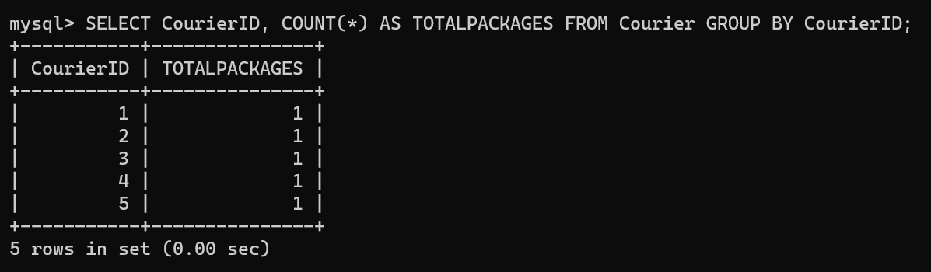

**10. Find the average delivery time for each courier**

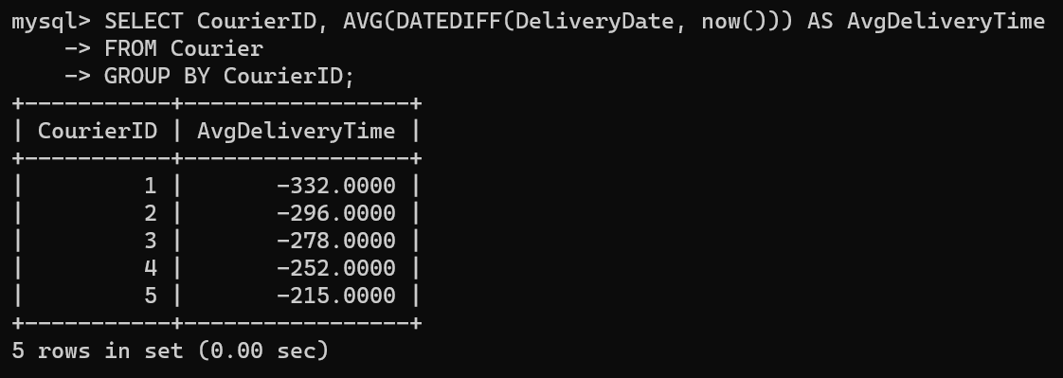

**11. List all packages with a specific weight range:**

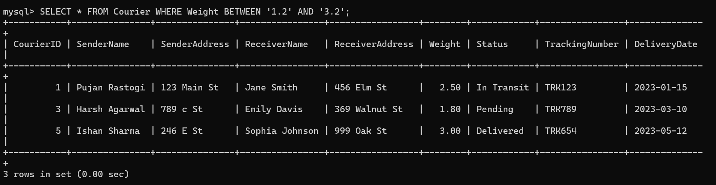

**12. Retrieve employees whose names contain 'Piyush Ag'**

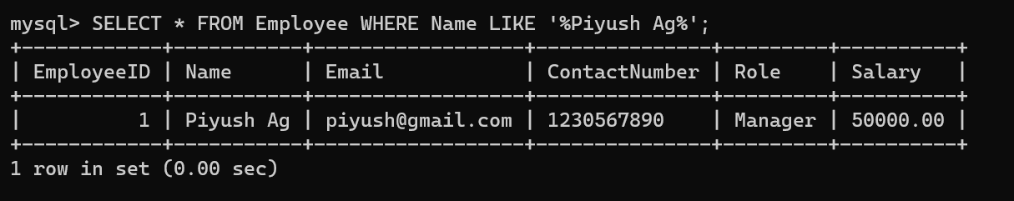

**13. Retrieve all courier records with payments greater than $50.**



**Task 3: GroupBy, Aggregate Functions, Having, Order By, where**

**14. Find the total number of couriers handled by each employee.**

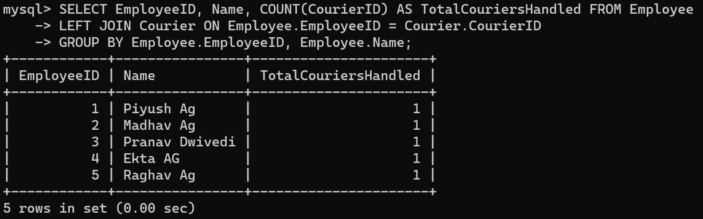

**15. Calculate the total revenue generated by each location**

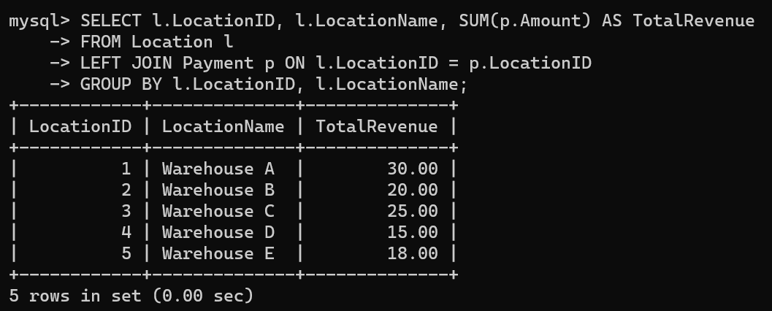

**16. Find the total number of couriers delivered to each location.**

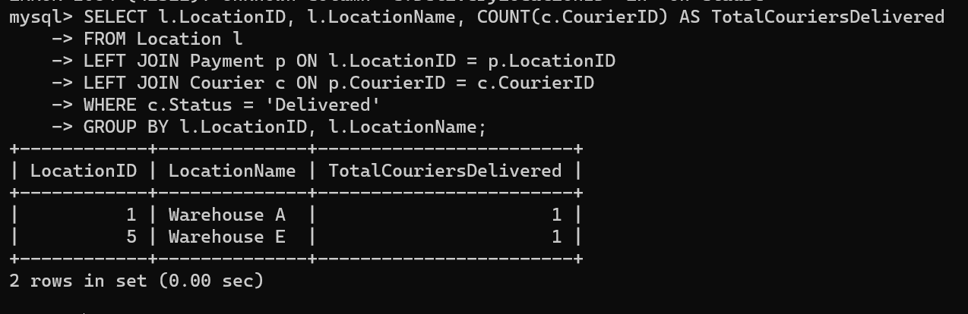

**17. Find the courier with the highest average delivery time:**

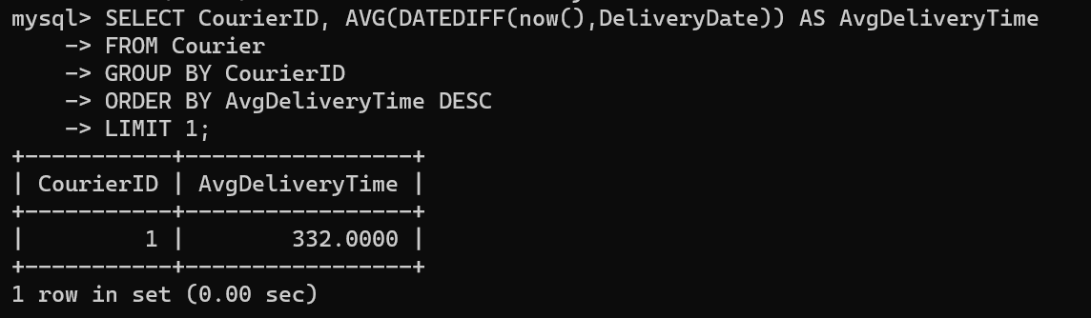

**18. Find Locations with Total Payments Less Than a Certain Amount**

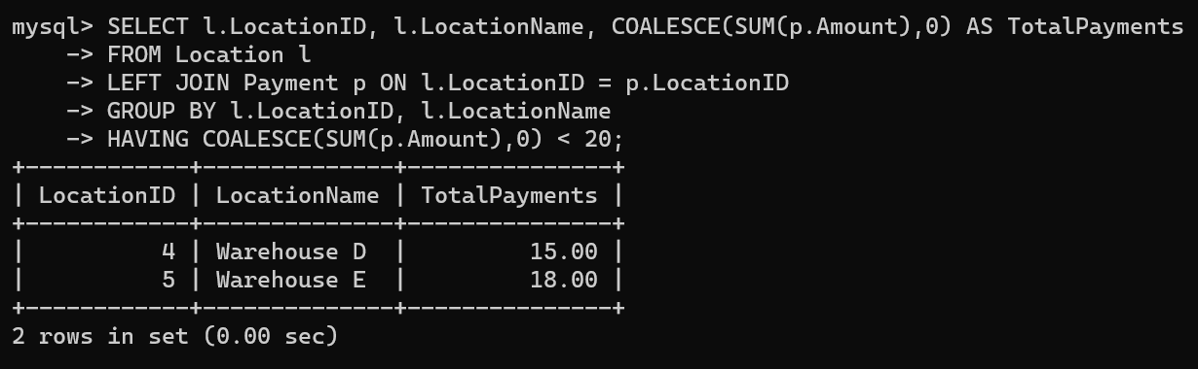

**19. Calculate Total Payments per Location**

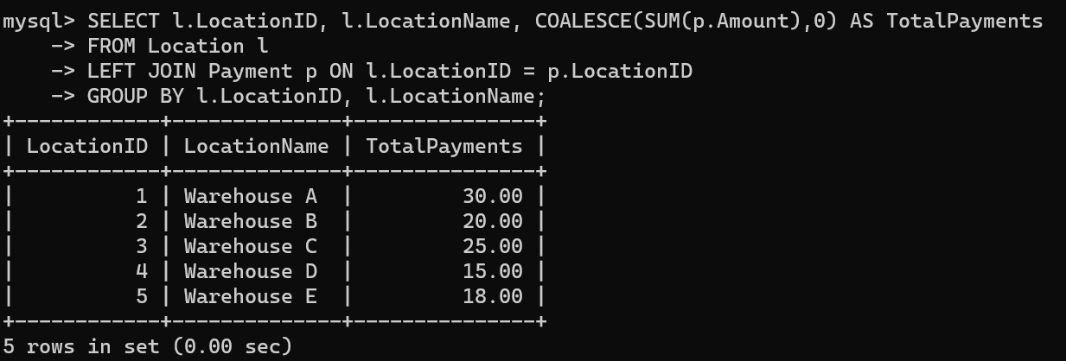

**20. Retrieve couriers who have received payments totaling more than $1000 in a specific location (LocationID = X):**

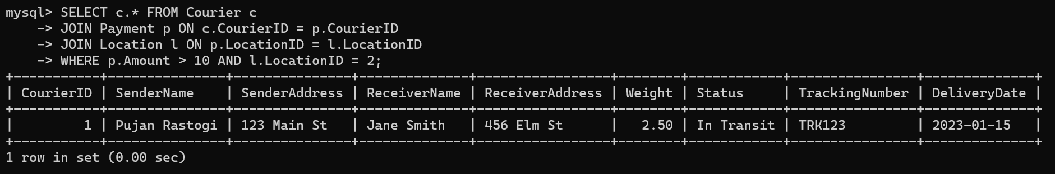

**21. Retrieve couriers who have received payments totaling more than $1000 after a certain date (PaymentDate > 'YYYY-MM-DD'):**

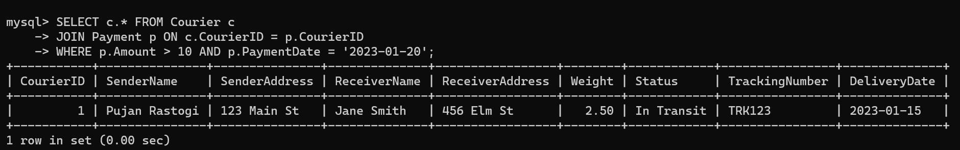

**22. Retrieve locations where the total amount received is more than $5000 before a certain date (PaymentDate > 'YYYY-MM-DD')**

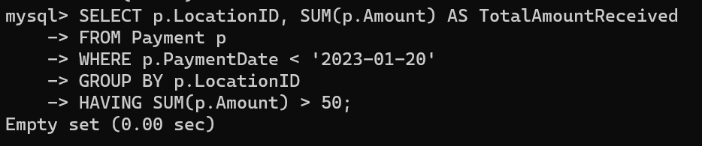

**Task 4: Inner Join,Full Outer Join, Cross Join, Left Outer Join,Right Outer Join**

**23. Retrieve Payments with Courier Information**

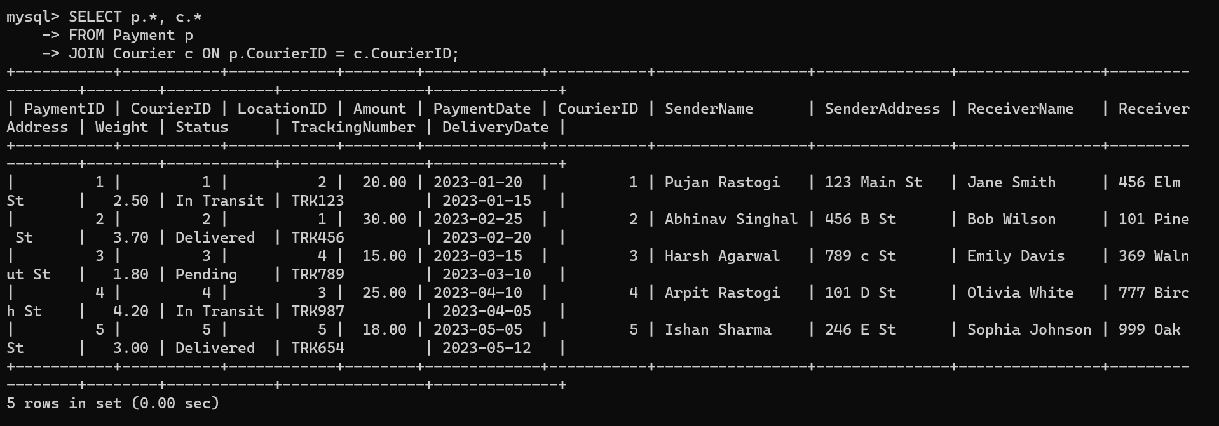

**24. Retrieve Payments with Location Information**

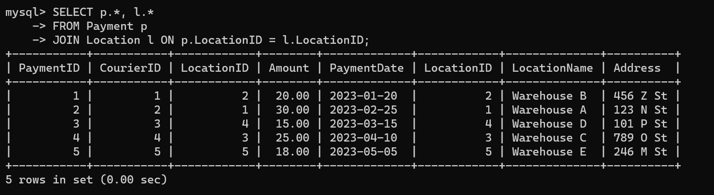

**25. Retrieve Payments with Courier and Location Information**

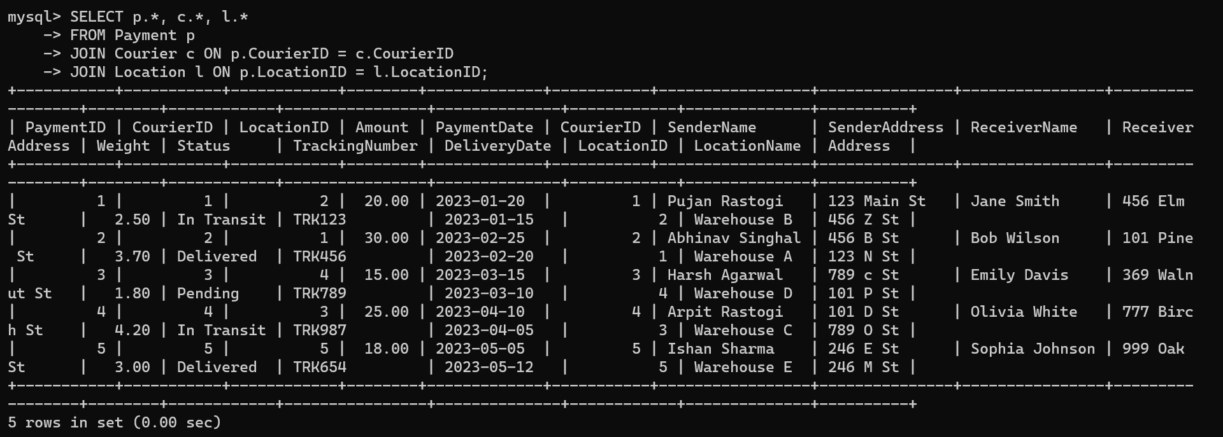

**26. List all payments with courier details**

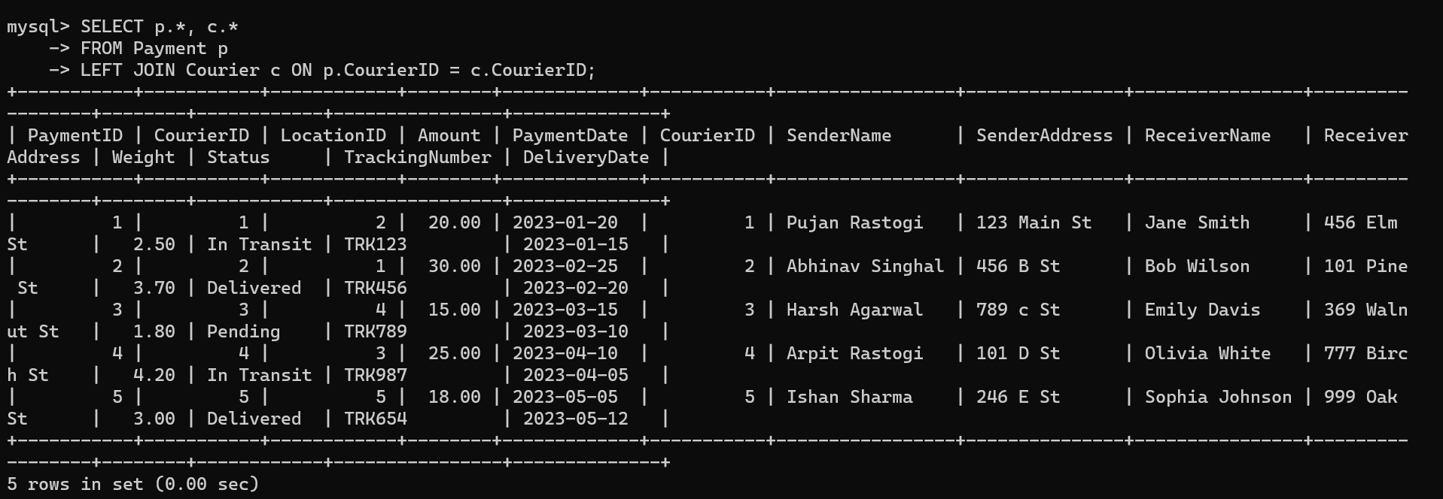

**27. Total payments received for each courier**

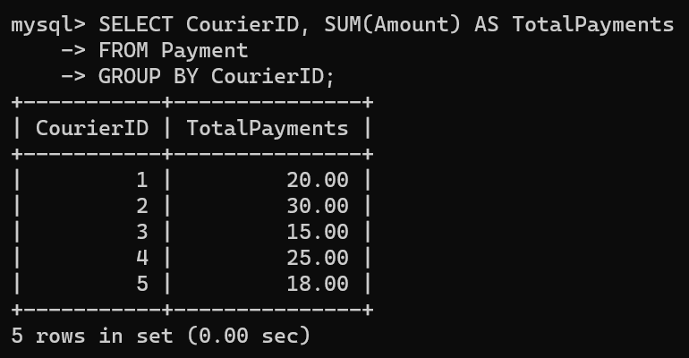

**28. List payments made on a specific date**

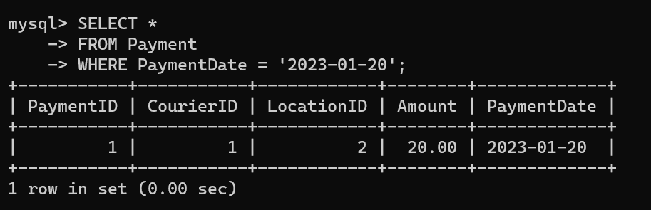

**29. Get Courier Information for Each Payment**

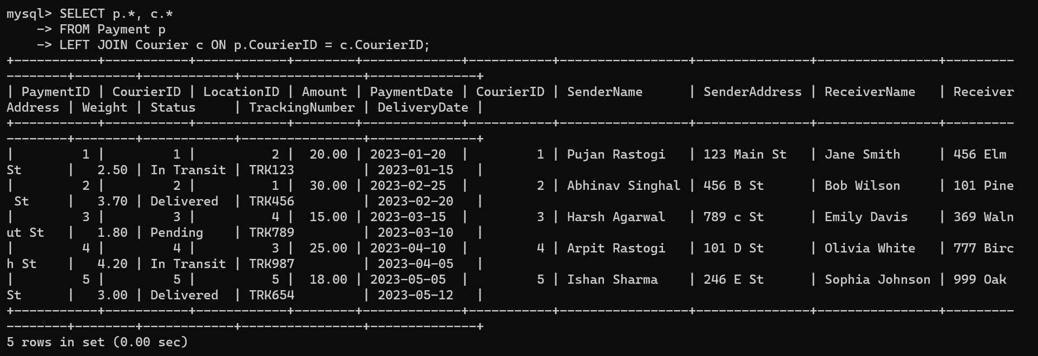

**30. Get Payment Details with Location**

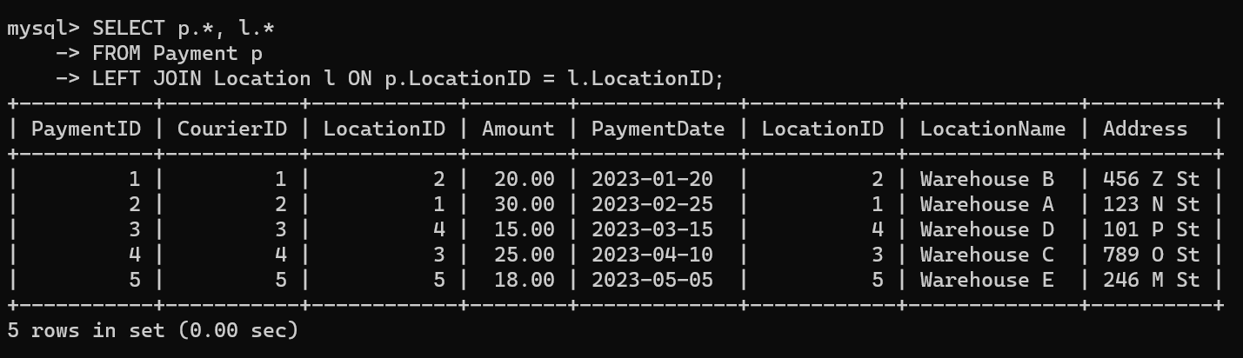

**31. Calculating Total Payments for Each Courier**

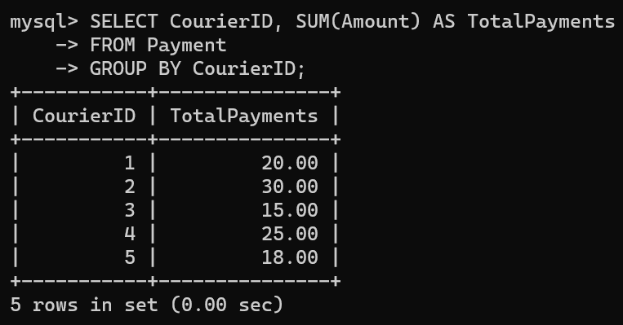

**32. List Payments Within a Date Range**

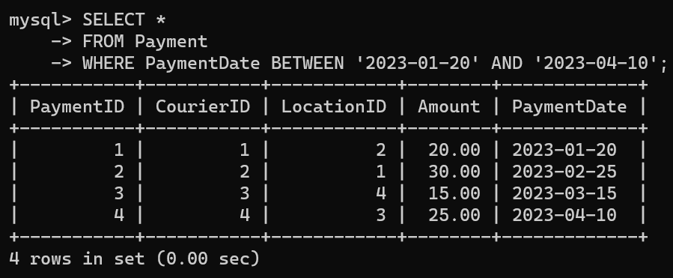

**33. Retrieve a list of all users and their corresponding courier records, including cases where there are no matches on either side**

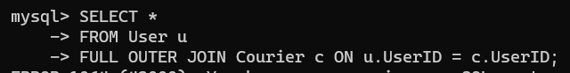

**34. Retrieve a list of all couriers and their corresponding services, including cases where there are no matches on either side**



**35. Retrieve a list of all employees and their corresponding payments, including cases where there are no matches on either side**



**36. List all users and all courier services, showing all possible combinations.**

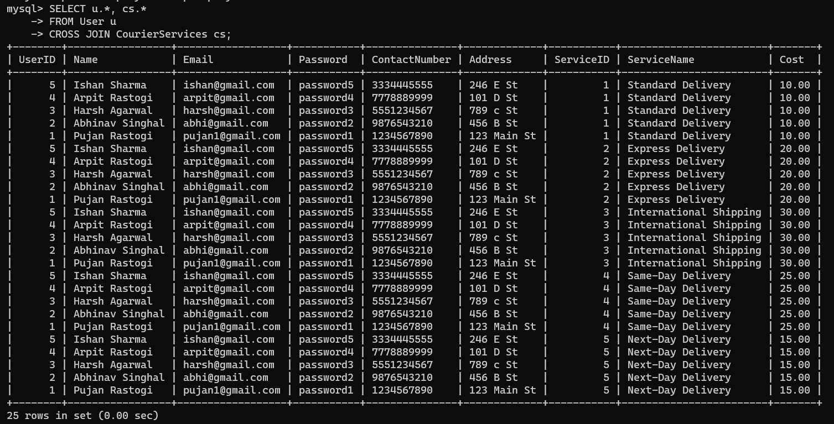

**37. List all employees and all locations, showing all possible combinations:**

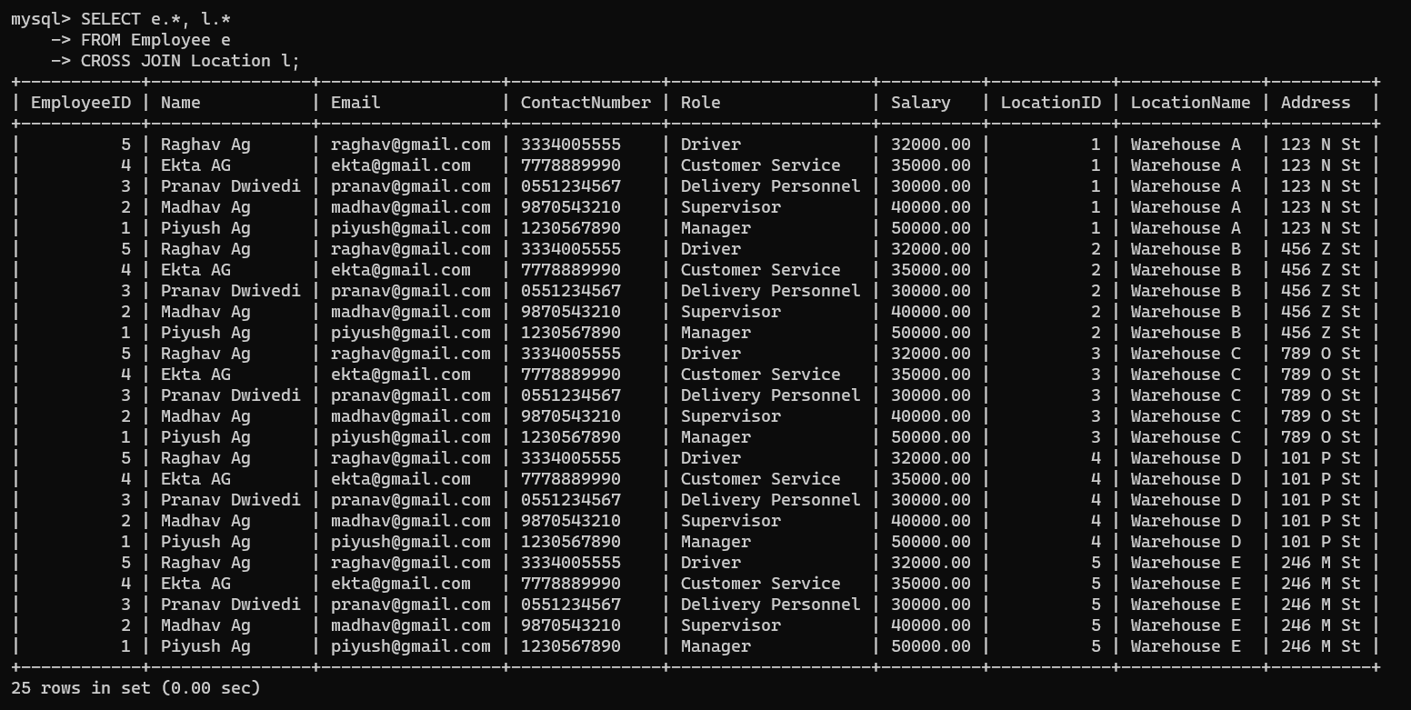

**38. Retrieve a list of couriers and their corresponding sender information (if available)**

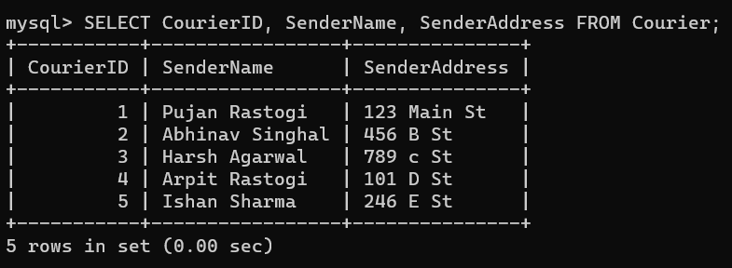

**39. Retrieve a list of couriers and their corresponding receiver information (if available):**

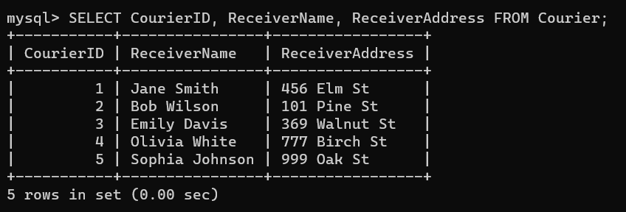

**40. Retrieve a list of couriers along with the courier service details (if available):**

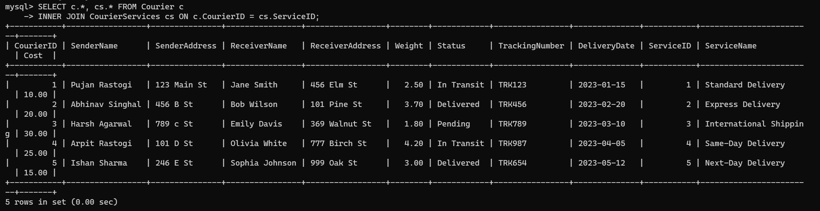

**41. Retrieve a list of employees and the number of couriers assigned to each employee:**

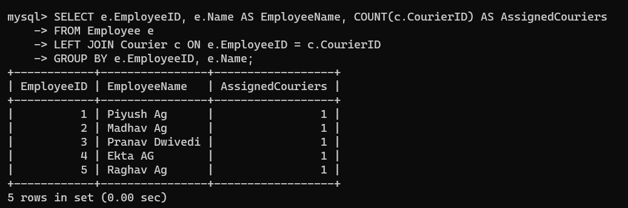

**42. Retrieve a list of locations and the total payment amount received at each location:**

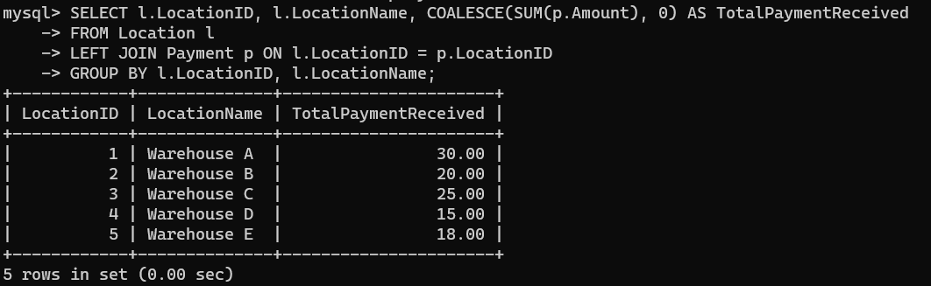

**43. Retrieve all couriers sent by the same sender (based on SenderName).**

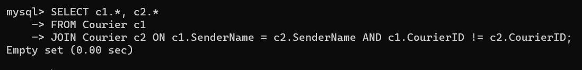

**44. List all employees who share the same role.**

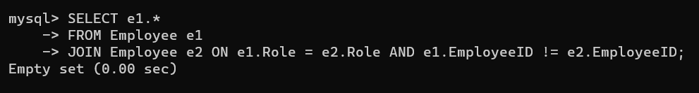

**45. Retrieve all payments made for couriers sent from the same location.**

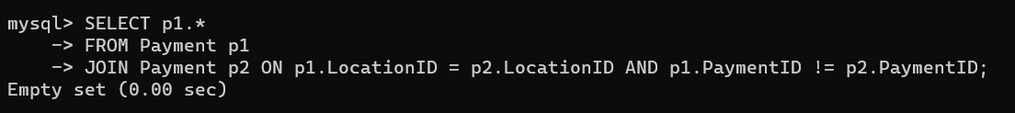

**46. Retrieve all couriers sent from the same location (based on SenderAddress).**

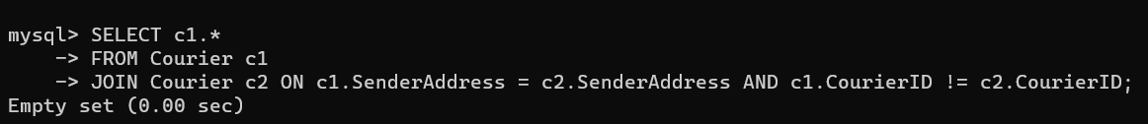

**47. List employees and the number of couriers they have delivered:**

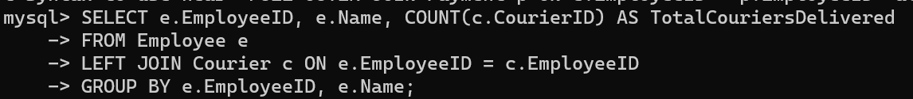

**48. Find couriers that were paid an amount greater than the cost of their respective courier services Scope: Inner Queries, Non Equi Joins, Equi joins,Exist,Any,All**

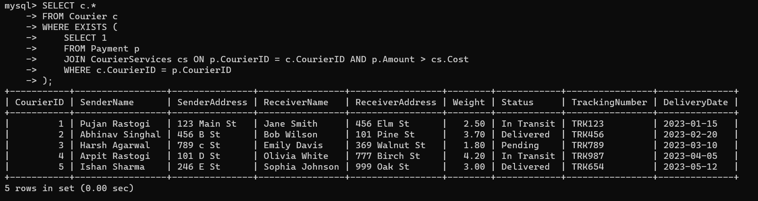

**49. Find couriers that have a weight greater than the average weight of all couriers**

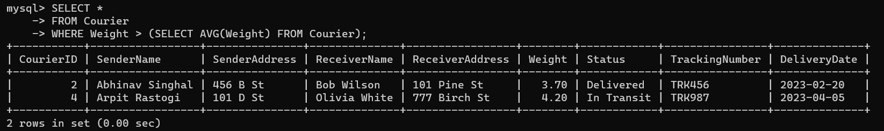

**50. Find the names of all employees who have a salary greater than the average salary:**

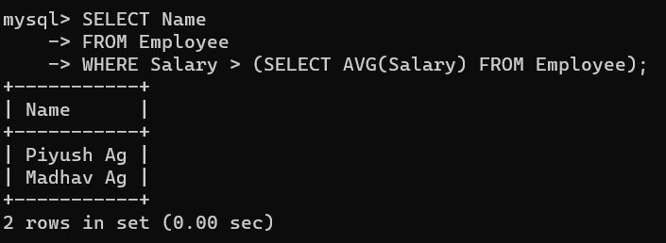

**51. Find the total cost of all courier services where the cost is less than the maximum cost**

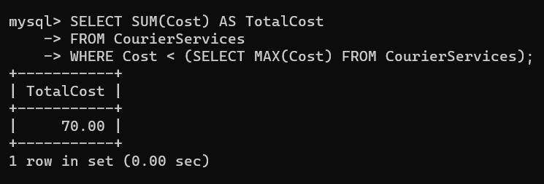

**52. Find all couriers that have been paid for**

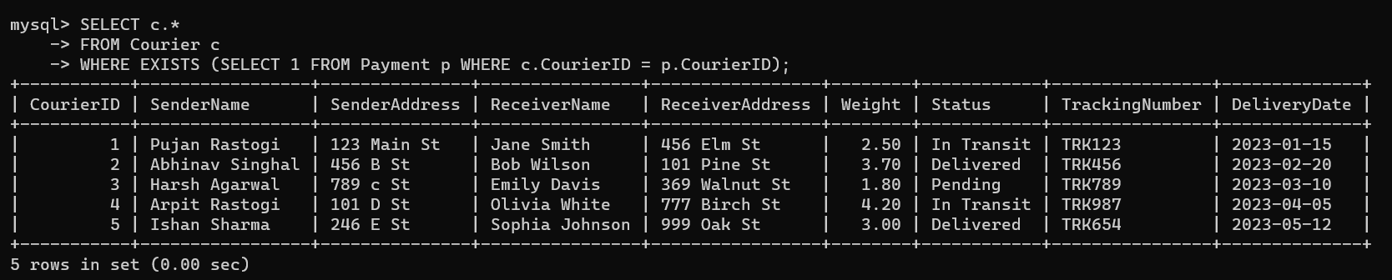

**53. Find the locations where the maximum payment amount was made**

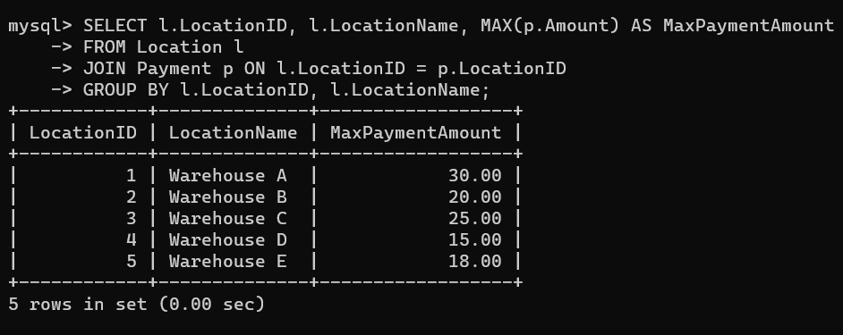

**54. Find all couriers whose weight is greater than the weight of all couriers sent by a specific sender (e.g., 'SenderName'):**

